***vRouter DPDK (Prototype)***

***Performance of MPLSoGRE traffic using Intel Dynamic Device Personalization (DDP) Technology for Fortville (X710) NICs***

**Authors:** Kiran KN <[kirankn@juniper.net](mailto:kirankn@juniper.net)>,

Przemysław Grygiel <[pgrygiel@juniper.net](mailto:pgrygiel@juniper.net)>

# ***Specifications***

## *Hardware*

|  |  |
| --- | --- |
| Model name | Intel(R) Xeon(R) Gold 5120 CPU @ 2.20GHz |
| CPUs | 56 |
| Sockets | 2 |
| Cores per Socket | 14 |
| Threads per core | 2 |
| NUMA 0 CPU list | 0,2,4,6,8,10,12,14,16,18,20,22,24,26,  28,30,32,34,36,38,40,42,44,46,48,50,52,54 |
| NUMA 1 CPU list | 1,3,5,7,9,11,13,15,17,19,21,23,25,27,  29,31,33,35,37,39,41,43,45,47,49,51,53,55 |

## 

## *Configuration of vRouter on compute-B (DUT):*

|  |  |
| --- | --- |
| Operating System | RedHat 7.7 |
| Number of Forwarding Cores | 6 (Physical) + 6 (Siblings) |
| Drop Rate | 0.001% |
| Bond | 2 x 10G (802.3ad LACP) with L3/L4 hash (Intel x710) |
| Hugepages | 1G |
| NUMA allocation | vRouter, NIC and VM on the same socket (NUMA 0) |
| Contrail version | 2003 GA |

## 

## *CPU allocation (Full-CPU partitioning scheme) on compute-B:*

|  |  |
| --- | --- |
| vRouter forwarding cores | 2,4,6,8,16,18,30,32,34,36,44,46 (6pcores/12 lcores) |
| Service cores | 0,1,28,29 |
| Control cores | 0,1,28,29 |
| Host OS cores | 0,1,28,29 |
| Kernel isolcpus and tuned isolcpu list | 2-27,30-55 |

## 

## *Traffic pattern*

|  |  |
| --- | --- |
| Number of flows | 16535 |
| Encapsulation | MPLSoGRE, MPLSoUDP |
| Packet size | 64B |
| Mode | Packet |

# ***Results***

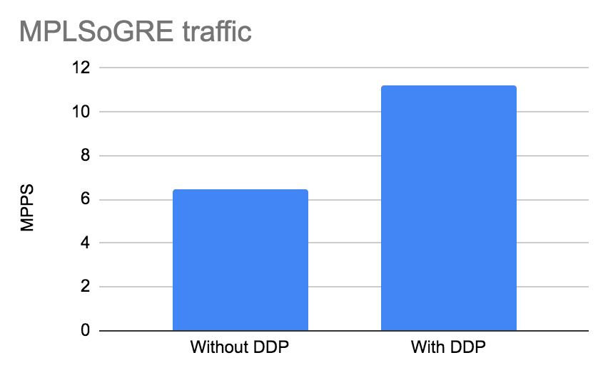

|  |  |  |  |  |
| --- | --- | --- | --- | --- |
| **Use case** | **Total**  **Mpps** | **Per core Mpps** | **Avg.**  **Latency** | **Max**  **Latency [us]** |
| **MPLSoGRE**  **without DDP** | **6.486** | **1.081** | **311** | **4154** |
| **MPLSoGRE with DDP** | **11.230** | **1.871** | **181** | **768** |
| **MPLSoUDP\*** | **11.140** | **1.857** | **162** | **720** |

## *DDP not needed as packets are hashed by NIC already

**Adding hashing of MPLSoGRE on Intel X710 improves performance by a phenomenal 73% and latency by 58%.**

## *Details for non DDP for 6 + 6HT*

|  |
| --- |
| +-------------------------------------------------------------------------------------------------------------------------------------------------------------------------+  | UDP, 64 bytes, different number of flows by randomizing SRC & DST UDP port |  +--------+--------------------+----------------+----------------+----------------+------------------------+----------------+----------------+----------------+------------+  | Flows | Speed requested | core generated | Sent by Gen NIC| Forward by SUT | core received | Avg. Latency | Max. Latency | Packets Lost | Loss Ratio |  +--------+--------------------+----------------+----------------+----------------+------------------------+----------------+----------------+----------------+------------+  | 16384 | 21.8% 3.244 Mpps | 3.243 Mpps | 3.243 Mpps | 3.243 Mpps | 2.2Gb/s 3.243 Mpps | 311 us | 4154 us | 92 | 0.00% |  +--------+--------------------+----------------+----------------+----------------+------------------------+----------------+----------------+----------------+------------+ |

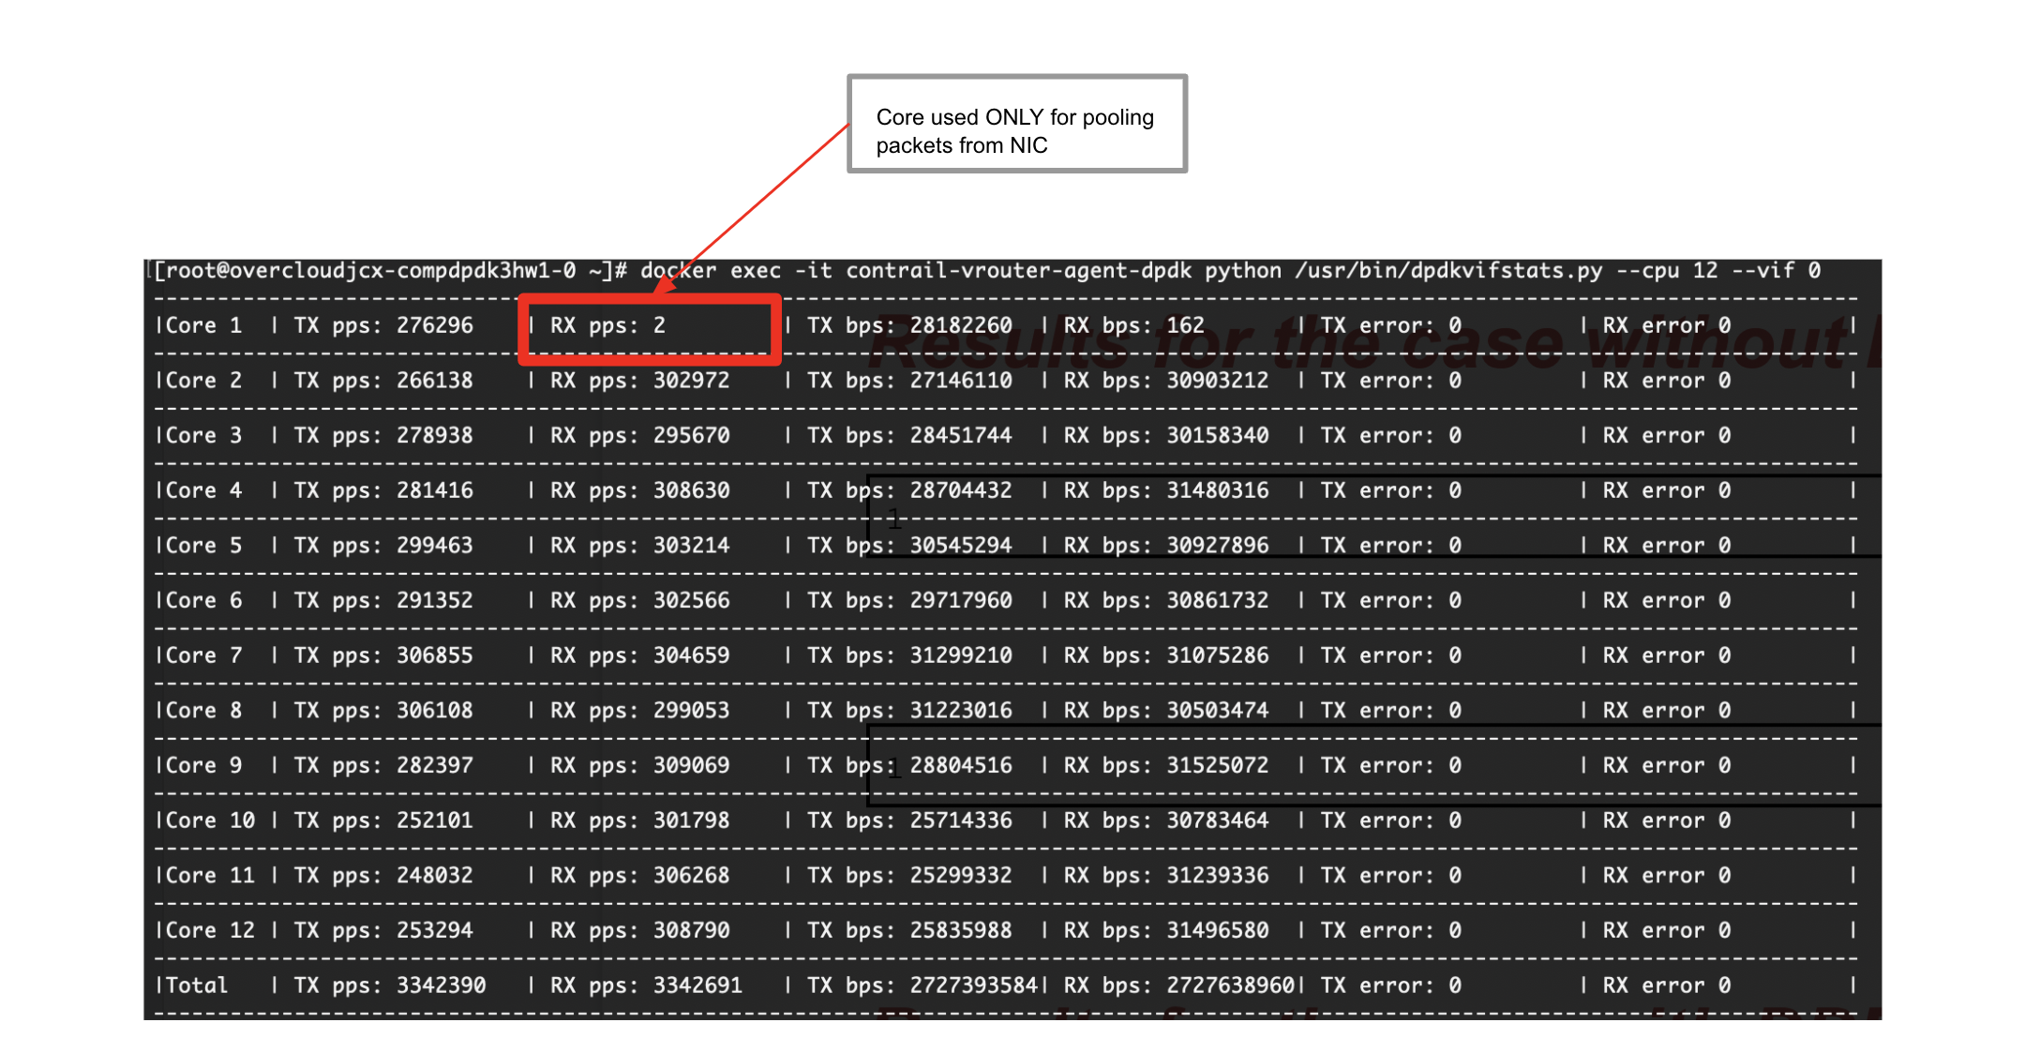

## *Results for the case with DDP for 6 + 6HT*

|  |
| --- |
| +-------+-------------------------------------------------------------------------------------------------------------------------------------------------------------------------+  | UDP, 64 bytes, different number of flows by randomizing SRC & DST UDP port |  +--------+--------------------+----------------+----------------+----------------+------------------------+----------------+----------------+----------------+------------+  | Flows | Speed requested | core generated | Sent by Gen NIC| Forward by SUT | core received | Avg. Latency | Max. Latency | Packets Lost | Loss Ratio |  +--------+--------------------+----------------+----------------+----------------+------------------------+----------------+----------------+----------------+------------+  | 16384 | 37.7% 5.615 Mpps | 5.615 Mpps | 5.615 Mpps | 5.615 Mpps | 3.8Gb/s 5.615 Mpps | 180 us | 767 us | 0 | 0.00% |  +--------+--------------------+----------------+----------------+----------------+------------------------+----------------+----------------+----------------+------------+ |

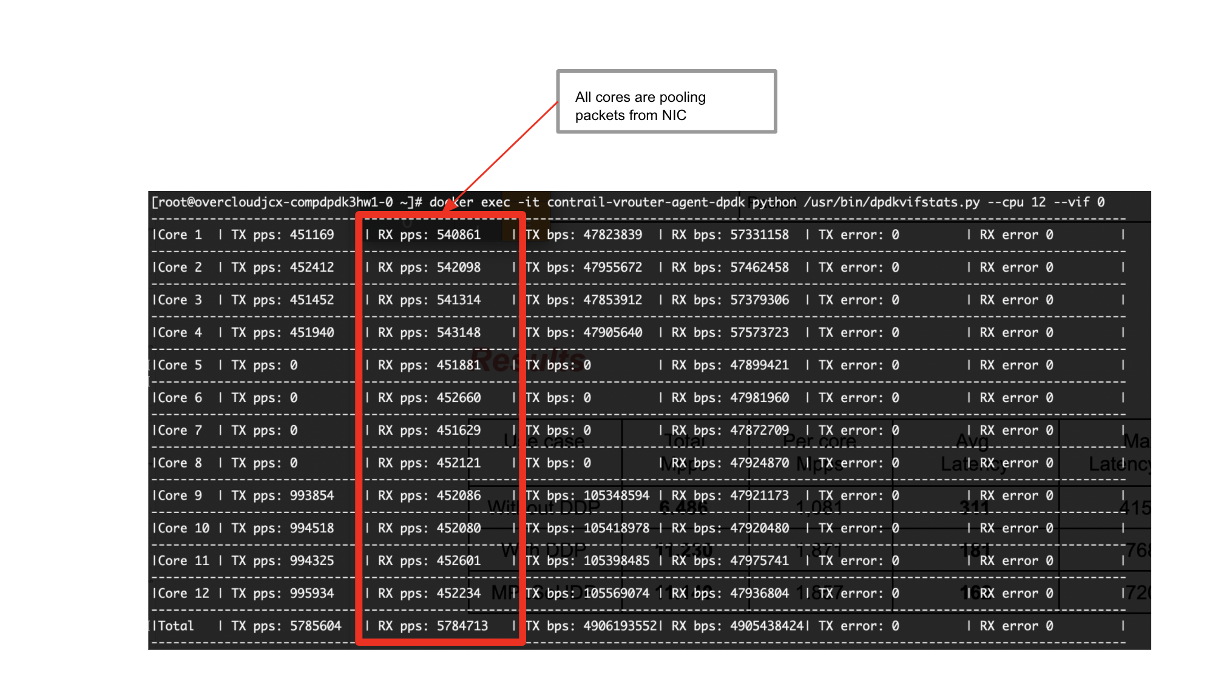

## *Results for the case with MPLSoUDP*

|  |
| --- |
| +-------  +-------------------------------------------------------------------------------------------------------------------------------------------------------------------------+  | UDP, 64 bytes, different number of flows by randomizing SRC & DST UDP port |  +--------+--------------------+----------------+----------------+----------------+------------------------+----------------+----------------+----------------+------------+  | Flows | Speed requested | core generated | Sent by Gen NIC| Forward by SUT | core received | Avg. Latency | Max. Latency | Packets Lost | Loss Ratio |  +--------+--------------------+----------------+----------------+----------------+------------------------+----------------+----------------+----------------+------------+  | 16384 | 37.4% 5.572 Mpps | 5.572 Mpps | 5.572 Mpps | 5.572 Mpps | 3.7Gb/s 5.572 Mpps | 162 us | 720 us | 0 | 0.00% |  | | Latency accuracy issue?: 12% |  +--------+--------------------+----------------+----------------+----------------+------------------------+----------------+----------------+----------------+------------+ |